Flow diagram – 2 operations

- Simply click on the textboxes that have the numbers and lines (underscores) in them and you can replace these with whatever you want.
- Select the whole group to cut and paste into your document
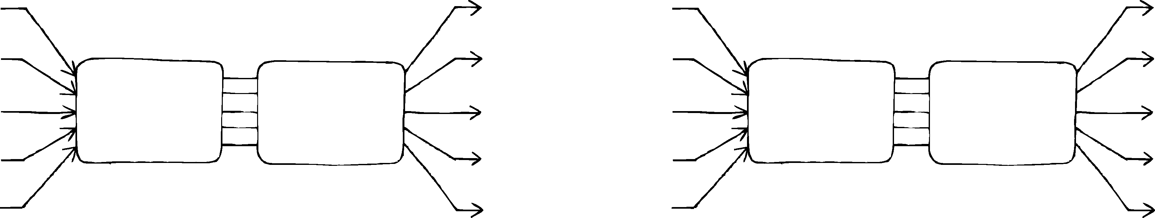
1234
1234
1234
1234
1234
÷ 55
× 22
1234
____
____
____
____

Flow diagram – 1 operation

- Simply click on the textboxes that have the numbers and lines (underscores) in them and you can replace these with whatever you want.
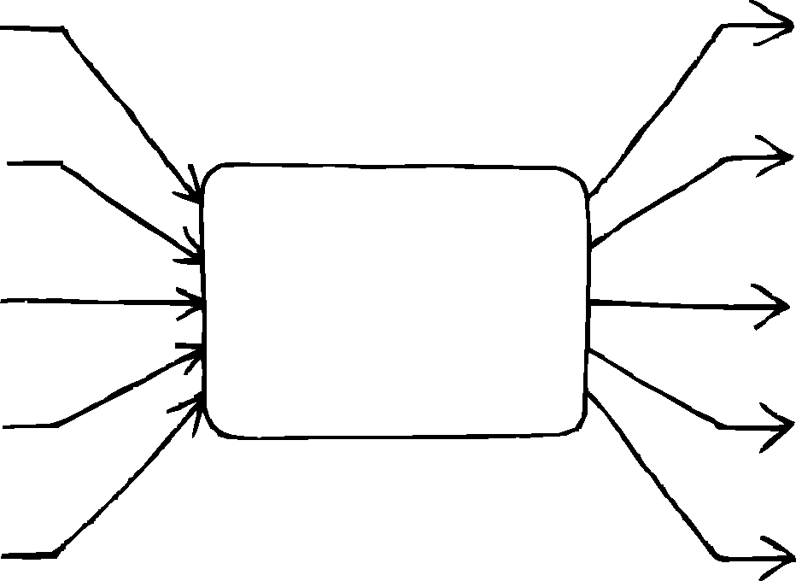
- Select the whole group to cut and paste into your document
1234
1234
1234
____
____
× 5
____
____
____
4567
4567

Short number chain

- Simply click on the textboxes that have the numbers and lines (underscores) in them and you can replace these with whatever you want.
- Select the whole group to cut and paste into your document
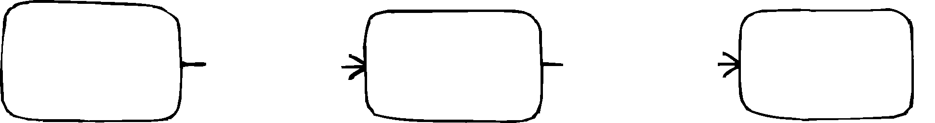
123

÷ 12
123
× 12
123

Long number chains

- Simply click on the textboxes that have the numbers and lines (underscores) in them and you can replace these with whatever you want.
- Select the whole group to cut and paste into your document
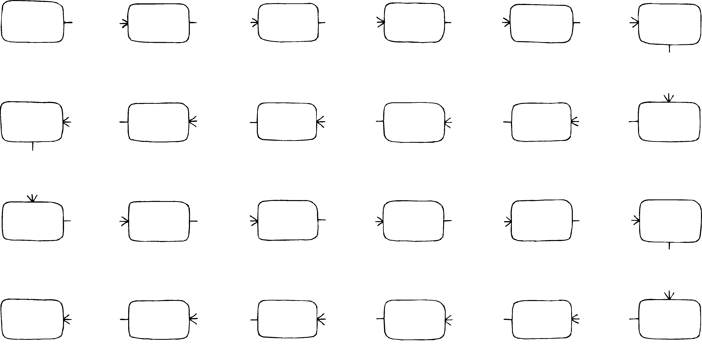
12
+ 2
13
+ 2
21
+ 3
24
+ 4
25
+ 3
28
- 3
28
+ 4
18
- 3
42
+ 6
36
+ 2
30
+ 5
25
+ 6
41
- 3
55
- 2
55
- 2
55
- 2
55
- 2
55
- 2
55
- 2
55
- 2
55
- 2
55
- 2
55
- 2
55

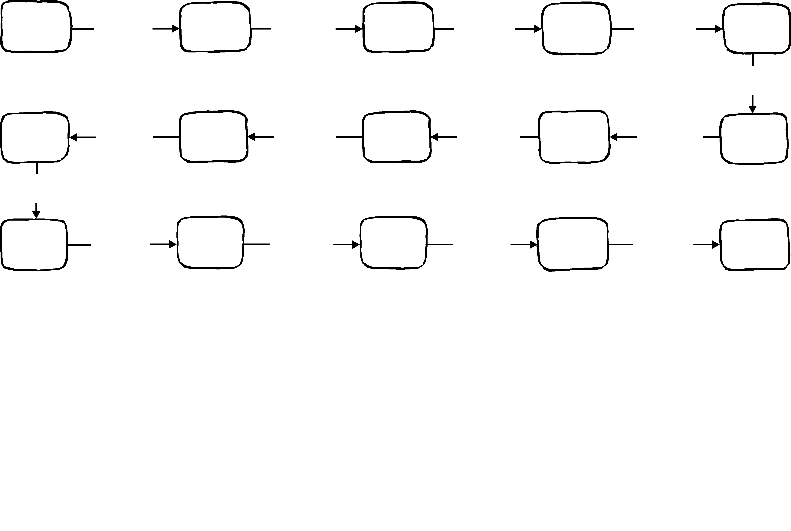
5
+5
+5
+5

+5

+5

+5

+5

+5

+5

+5

+5

+5

+5
+5
5

5
5
5

5

5
5

5

5
5

5
5
5
5

Number line

- Simply click on the textboxes that have the numbers and lines (underscores) in them and you can replace these with whatever you want.
- Select the whole group to cut and paste into your document

15
14
13
13
13
13
13
13
13

Pyramids

- Simply click on the textboxes that have the numbers and lines (underscores) in them and you can replace these with whatever you want.
- Select the whole group to cut and paste into your document
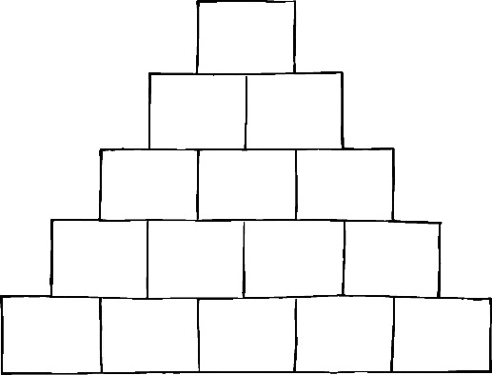
10
11
12
13
14
22
24
24

24

47
24

24

24

24

24

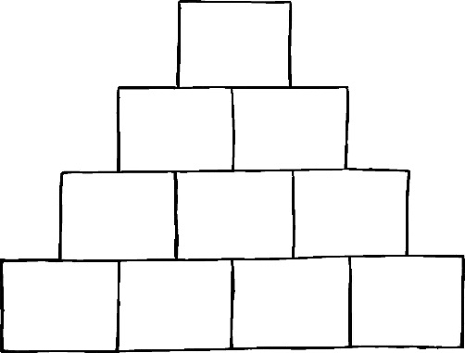
2
2
2
2
2
2
2
2
2
2

Tables

- Simply click on the textboxes that have the numbers and lines (underscores) in them and you can replace these with whatever you want.
- Select the whole group to cut and paste into your document.
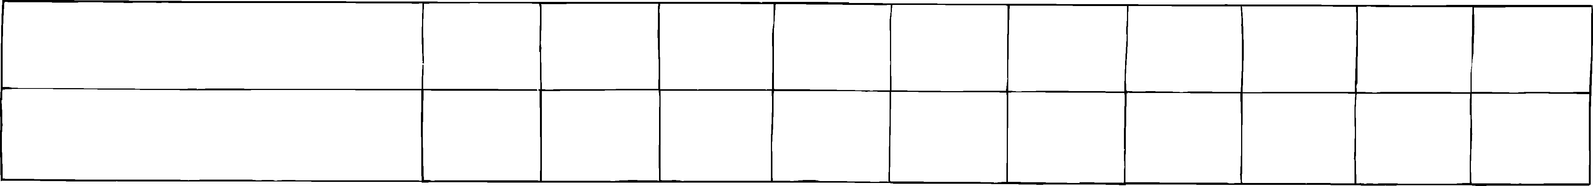
Input number
1
2
3
4
5
6
8
9
10
Output number
3
10
21
36

36
28
7
25
28
28
36

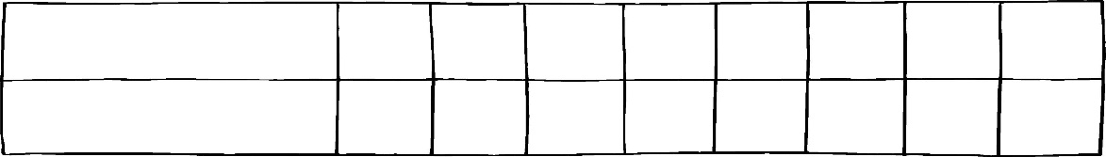
Hands
2
Fingers
10
4
20
8
20
9
20
10
20
11
20
12
20
13
20

